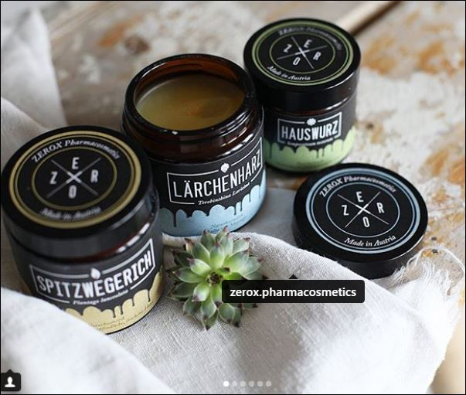

©freiraum.14

